6 Way Horizontal Surge Protected Rackmount Schuko Plug PDU - 16A Schuko Sockets (PDU-6WS-H-SCH-SCH-SP)

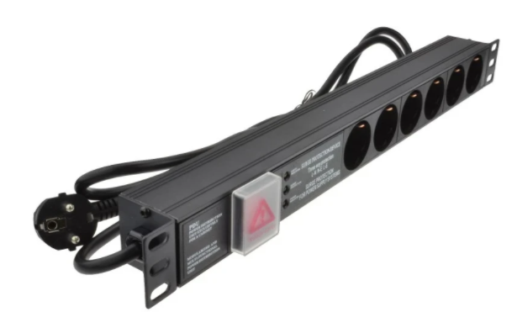

Description:
The LMS Power PDU-6WS-H-SCH-SCH-SP is a high-quality horizontally mounted PDU (Power Distribution Unit) that simply fits within the universal mounting brackets of data, telecom and server cabinets.
Providing piece-of-mind of integral electrical surge protection against common power surges and electrical spikes to devices including Ethernet Switches, Servers, UPS, NAS and of course cabinet accessories including cooling fan trays.
Robust, alloy design complete with rackmount brackets fitted, high-quality Neon Switch, high-load standardised 16 A rated Schuko power input plug connected to Schuko output power sockets.

Key Features:
Standard Schuko power outlets for your appliances
Built-in surge protection for critical device protection
Standardised Schuko 16 Amp power plug
1U horizontally mounted attaches to internal profiles
Neon On/Off Rocker switch to prevent accidental turn off
Backed up by LMS Power's exclusive 3-year warranty

Applications:
Create instant power feeds to your data, telecom or server cabinets
Provide effective power for cabinet cooling fans, UPS systems
Ideal as stand-alone trailing sockets outside the cabinet

Product Code:
Part Number: PDU-6WS-H-SCH-SCH-SP
EAN: 8400800033321
Weight: 1.5Kg approx

Technical Specifications:
Warranty LMS Data 3-Year Warranty
Chassis 1U horizontally PDU with mounting brackets
Output Sockets 6 Schuko Sockets
Power Input Standardised Schuko Plug
Flex Length 1.8 metres (approx)
Power Control On/Off Rocker Switch (illuminated)
Power Rating 4000 Watts (approx) Surge Protected

Supplied With:
PDU-6WS-H-SCH-SCH-SP 6 Way Horizontal PDU
Cabinet brackets (Fitted)
* Specifications and product design are subject to change. E&OE.

Looking for high-performance power distribution for your heavily-loaded systems, with the piece of mind of integral electrical surge protection? The newly developed LMS Data PDU-6WS-SCH-SCH-SP is an industrial grade full Schuko,16-Amp compatible, 6- way power strip which also incorporates the Schuko plug input on a 2-metre compatible power flex. Popular in the EU, the Schuko connector is ideal for many professional and industrial applications that need extra power throughput. Robust in design, with an integral neon illuminated rocker switch for assured functionality, the LMS Data PDU is designed to deliver maximum electrical power today and tomorrow.

specifications:
Horizontal, high-density Power Distribution Unit (PDU)
Industry-standard Schuko 16-Amp input Plug
Integral surge-protection input circuitry
Compatible, heavy-load power flex
6x 16-Amp Schuko type power outlets
Robust, black aluminium design for industrial use
Neon on/off power switch for assured control
Maximum power rating - 4000W approx.
2.0 metre (approx.) extra-length power cordage

